HUMBOLDT BAY HARBOR, RECREATION AND CONSERVATION DISTRICT
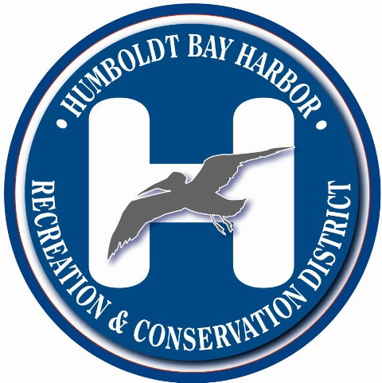

P.O. BOX 1030
Eureka, California 95502
phone (707) 443-0801
fax (707) 443-0800

PERMIT APPLICATION
Date Filed_______________

Describe in detail the proposed project:
6.) Existing City/County Zoning
5.) List and describe any other related Project Permits & Other Public Approvals required, including those required by City, Regional, State & Federal Agencies.
C. Date Accepted for filing by Commission
D. Date of Public Notice
E. Date of Environmental Compliance
F. Date of Public Notice
G. Date of Public Hearings
H. Date of Commission Action

Approval: _________
Conditional _______
Disapproval _______
I. Expiration Date
Comments
7.) Proposed Site Use (Project Title)
4.) Attach list of names and addresses of all adjoining property owners
3.) Contact person Name, Address, phone #

1.) Name, Address, phone # and email of Developer, Project Sponsor and Legal Owner
B. Date Received by Harbor District
2.) Address of Project and Assessor’s block, lot and Parcel Number
A. Application No.

Application Type:
Franchise
Permit
Lease
For Commission Use
General Information

Describe proposed project

Answer all questions completely on a separate page. If the question does not apply to your project, so indicate by marking N.A. Contact Harbor District Office with questions.

PROJECT DESCRIPTION

- Site Size
- Square Footage
10. Number of floors of construction
11. Amount of off-street parking provided
- Attach plans
- Proposed scheduling
- Associated projects
- Anticipated incremental development
- If residential, include the number of units, schedule of unit sizes, range of sale prices or rents, and type of household size expected.
- If commercial, indicate the type, whether neighborhood, city or regionally oriented, square footage of sales area, and loading facilities
- If industrial, indicate type, estimated per shift employment & loading facilities.
- If institutional, indicate the major function, estimated per shift employment, occupancy, loading facilities, and community benefits derived from the project.
- If the project involves a variance, conditional use or recognizing application, state this and indicate clearly why the application is required.

Are the following items applicable to the project or its effects? Answer yes or no. Discuss all items answered yes.

- Change in existing features of any bays, tidelands, beaches, lakes or hills, or substantial alteration of ground contours.

- Change in scenic views or vistas from existing residential areas or public lands or roads.

- Change in pattern, scale or character of general area of project.

- Significant amounts of solid waste or litter.

- Change in dust, ash, smoke, fumes or odors in vicinity.

- Change in ocean, bay, lake, stream or ground water quality or quantity, or alteration of existing drainage patterns.

- Substantial change in existing noise or vibration levels in the vicinity.
A. During Construction
B. During Project Utilization

- Site on filled land or on slope of 10% or more.

29. Use of disposal or potentially hazardous materials, such as toxic substances, flammable or explosives.

- Substantial change in municipal services demand (police, fire, water, sewage, etc.)

31. Substantially increase fossil fuel consumption (electricity, oil, natural gas, etc.).

32. Relationship to larger project or series of projects

ENVIRONMENTAL SETTING:

- Describe the project site as it exists before the project including information on topography, soil stability, plants and animals, and any cultural, historical, or scenic aspects. Describe any existing structures on the site and the use of the structures. Attach photographs of the site. Photos will be accepted.

34. Describe the surrounding properties, including information on plants and animals and any cultural, historical, or scenic aspects. Indicate the type of land use (residential, commercial, etc.) intensity of land use (one-family, apartment houses, shops, department stores, etc.) and the scale of development (height, frontage, set-back, rear yard, etc.) Attach photographs of the vicinity. Photos accepted.

----------------------- Questions 35; and 36 MUST BE ANSWERED! -------------------
35. How will the proposed use or activity promote the public health, safety, comfort, and convenience?

36. How is the requested grant, permit, franchise, lease, right, or privilege required by the public convenience and necessity?
----------------------------------------------------------
- Financial statement:
A. Estimated project cost.
B. How will the project be financed?

- Describe fully directions necessary to arrive at project site.

- The Applicant agrees to as a condition of the permit being issued, to indemnify and hold harmless the Humboldt Bay, Harbor Recreation and Conservation District from any and all claims, demands, or liabilities for attorneys’ fees obtained from or against demands for attorney’s fees, costs of suit, and costs of administrative records made against District by any and all third parties as a result of third party environmental actions against District arising out of the subject matter of this application and permit, including, but not limited to, attorney’s fees, costs of suit, and costs of administrative records obtained by or awarded to third parties pursuant to the California Code of Civil Procedure Section 1021.5 or any other applicable local, state, or federal laws, whether such attorneys’ fees, costs of suit, and costs of administrative records are direct or indirect, or incurred in the compromise, attempted compromise, trial, appeal, or arbitration of claims for attorneys’ fees and costs of administrative records in connection with the subject matter of this application and permit

NOTE
The District hereby advises the Applicant that, under California Public Resources Code (PRC) Section 21089, the District when a lead agency under the California Environmental Quality Act (CEQA) of 1970, as amended, pertaining to an Environmental Impact Report (EIR) or a Negative Declaration (MND/ND) may charge and collect from the Applicant a reasonable fee in order to recover the estimated costs incurred by the District in preparing an EIR or MND/ND for the project and the procedures necessary for PRC compliance on the Applicants project.

In the event your project contains an analysis of issues pertaining to CEQA, for which District staff is not competent to independently review, or District requires the same in preparation of an EIR or MND/ND for the project, the District may retain a reviewing consultant to evaluate the content of the Administrative-Draft EIR and Final EIR or MND/ND with respect to these issues. The cost of such reviewing consultant services shall be borne by the Applicant.

CERTIFICATION: I hereby certify that the statements furnished above and in the attached exhibits present the information required for this initial evaluation to the best of my ability, and that the facts, statements, and information presented are true and correct to the best of my knowledge and belief. And I agree to indemnify the District as described in part 39 of this application.

Dated:_________________________ __________________________

For________________________

